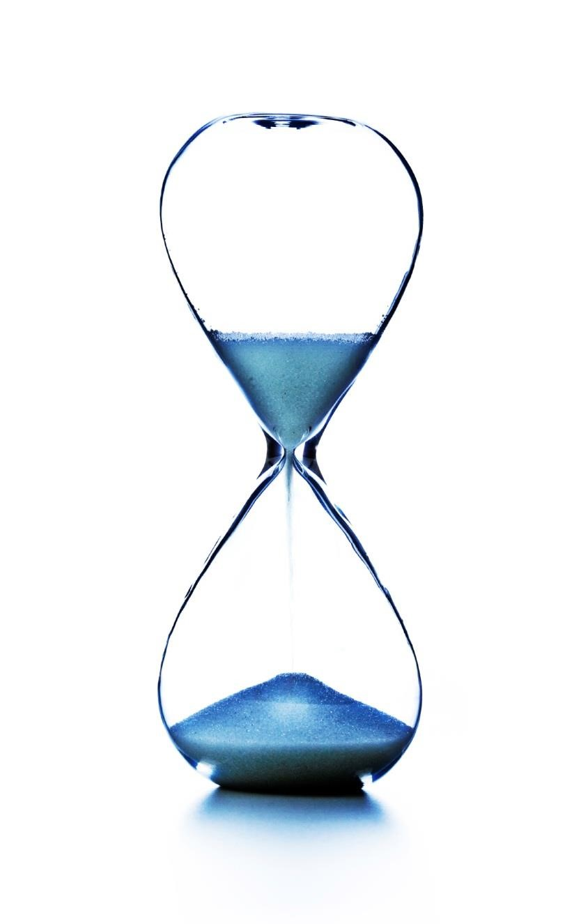
2023

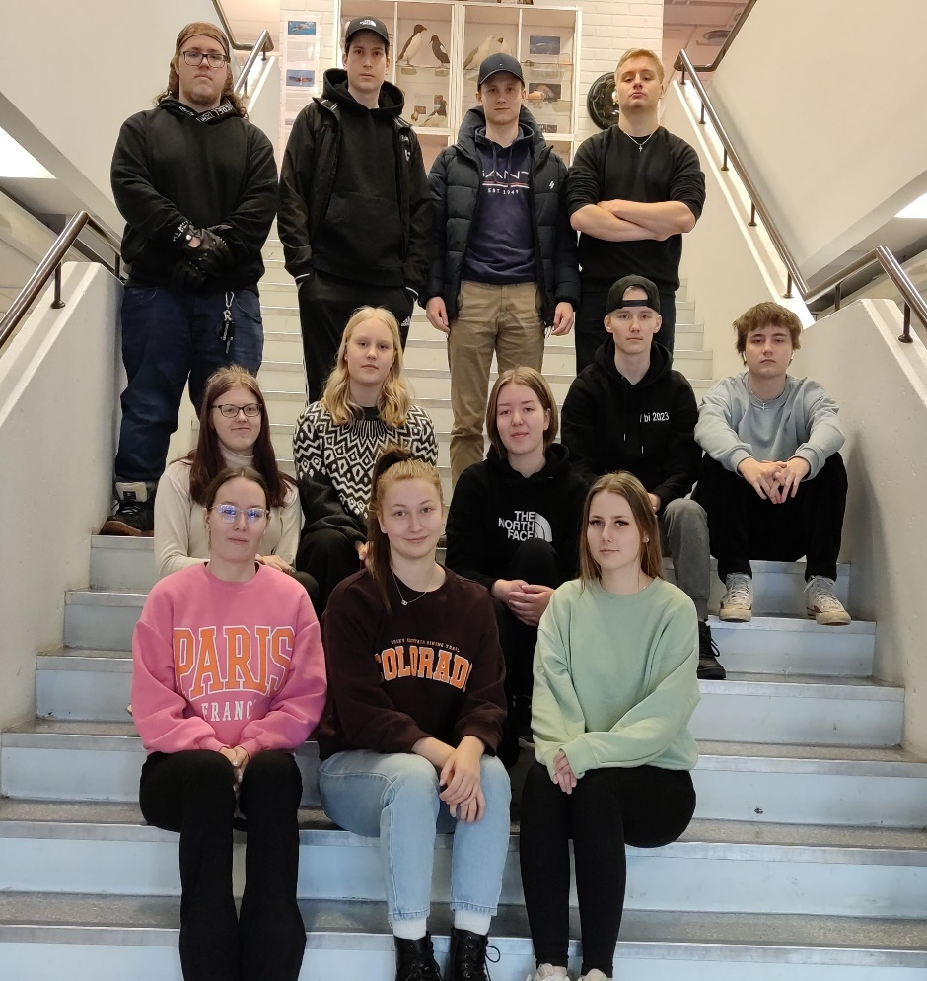

You are reading Kokemäki Leaks, the greatest high school paper of all time, and this year’s paper is pure gold. It's made by Kokemäki high school's greatest and bravest soldiers who had the power to join the scariest course ENA11. Our –04 soldiers in 2023 have written news articles with tears in their eyes and their computers on fire. Janette, Niko, Mette, Emmi, Aleksi, Noora, Simo, Minttu, Karri, Juho, Isabella and Hannu have successfully been creative and have found mind-blowing topics in this bored country with boring news. We will give this gold to your hands with full pride and joy.
In 2020-2023 we have faced many huge world crises, but we have survived of the challenges they have brought to our lives. We have spent several hours at the school gymnasium doing matricular examinations and eating our sugar-laden snaks. This year has also included many shopping trips during the breaks between classes because of the huge amount of energy drink and candy needed, especially by third year students which have melted into the couches
We are sure that everyone will enjoy this world's best school paper of all time. Your conscious mind will blow after this, and you will know something new. This will be one of the biggest experiences of your life. Enjoy.
Emmi Kangas

SCHOOL
An Interview with Aino Ylijoki
Last autumn a new teacher arrived at Kokemäki junior high school. I interviewed her via Wilma. Here are the questions and the answers.
- Introduce yourself. Who are you, where do you come from, what do you do and how long have you worked at Kokemäki junior high school?
- I’m Aino Ylijoki. I live in Lieto, and I teach visual arts at Kokemäki junior high school and high school. I started as a visual arts teacher last August.
- What have you thought of Kokemäki junior high school?
- Kokemäki junior high school is a nice place to work, and the students have been nice.
- What interests you in visual arts?
- I’m a visual person and observant by character so looking at different pictures has always been pleasing to me. I’m interested in visual arts also via doing it myself. When you try to make a picture from some subject yourself, you get interested in how other people have depicted it.
- What is your favorite thing in visual arts?
- I always like to try new techniques or subjects. From the traditional techniques maybe ceramics, graphics and drawing are my favorite.
- What have you studied and how long have you been a teacher?
- I have studied visual arts education and I graduated as an art teacher in 2008.
- Has teaching been your dream profession since you were a child?
- Maybe not that long. In middle school I was inspired by my own visual arts teacher and there I had the first thought of being a visual arts teacher.
- What do you like to do in your free time?
- Usually, my free time goes with my kids. I have two kindergarten age children, so I don’t have problems with spending my free time. If I don’t have any plans, they will make plans for me.
- Do you have any plans for the future?
- In the future I would like to learn more about digital drawing.
Minttu Peltonen

Sydän-Satakunta visit
Our group had an amazing opportunity to visit the Sydän-Satakunta newsroom. We were in the heart of the newspaper and there were professional journalists telling us about making a newspaper. What a dream!
The Sydän-Satakunta editor-in-chief Timo Simula happily welcomed us in the office. He started talking about the newspaper that was published on the exact day. He asked his co-workers Arja Harjunmaa and Jussi Rakkolainen to join and tell us about their stories from the paper. Quickly the conversation turned into a general discussion about journalism and the work of journalists.
They told us how Covid-19 affected their work and content. For example, they had to do distance working and they couldn’t do polls anymore because people weren’t allowed to meet each other. Sometimes it can be hard to write something without being present.
Simula and Harjunmaa also told us something of their previous summer journalists. The names that popped up were Ilari Leppäniemi, Nina Rahkola, Juha Karilainen and Saara-Maria Tunturi. I looked them up on the internet and checked what they are doing today. You can find Karilainen’s and Tunturi’s texts from Valkeakosken Sanomat, Aamulehti, Satakunnan Kansa and Iltalehti. Rahkola is a journalist but she’s also a host of MTV3's Huomenta Suomi and she hosts different events too. Leppäniemi is our school’s former student and so is Tunturi. I found Leppäniemi’s stories from Sydän-Satakunta, Aamulehti and Valkeakosken Sanomat.
We also discussed the feedback they have got. The journalists at the office said that getting feedback is a good thing, even if it’s not positive. Criticism helps journalists to become better. Simula said that he has got both types of feedback, but he is experienced so he can handle it. He also said that a good journalist can ask difficult questions and face people.
Our visit was successful, and I learnt a lot. It was nice to get to know another profession and I liked that the journalists were open with us. It’s not easy to be a journalist!
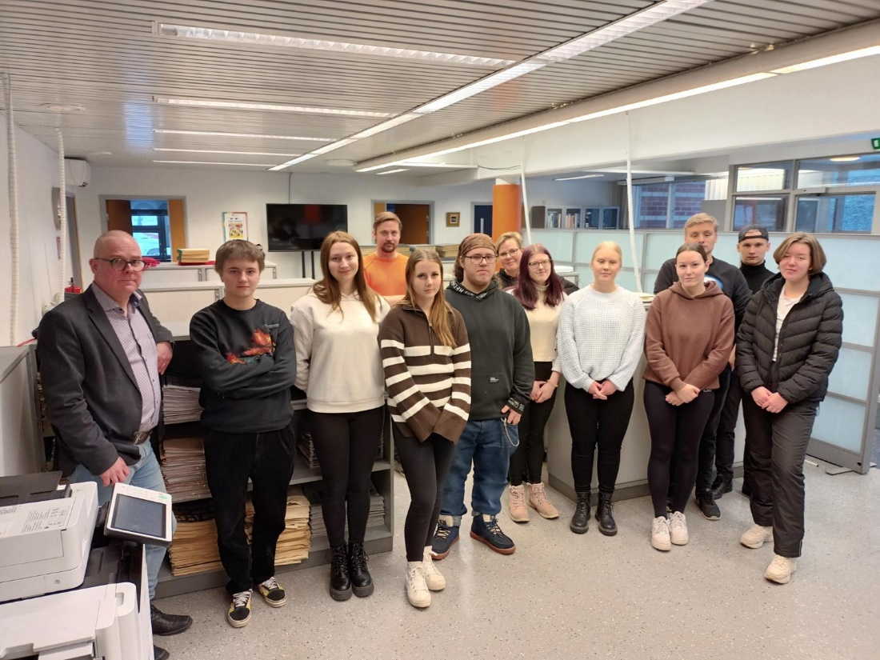
Minttu Peltonen

Which grocery store is visited the most by the third-year students of Kokemäki High School?
There are three grocery stores in Kokemäki: S-market, K-Supermarket Teljänportti and Lidl. I wanted to find out which of them the third-year students of Kokemäki High School prefer to visit and why. I interviewed six students with two questions. My first question was which grocery store do you prefer to go to and my second question was why do you prefer to go to this grocery store.
Riina said that she prefers to go to S-market. Riina was of the opinion that S-market is better than K-Supermarket because it is cheaper there than in the K-Supermarket and there you can get everything you need.
Also Fanni said that she prefers to go to S-market because it is cheap there and there are many Finnish products there. Fanni also mentioned that S-market often has a 30 percent sale on products that turns into a 60 percent sale in the evening, which is a good thing for students who are usually poor.
Emmi said that she prefers to go to K-Supermarket because it is small and cozy and you can find special products there. Emmi also said that S-market would be a better store in terms of price but the selection there is worse than in K-Supermarket.
Minttu said that she prefers to go to S-market. She has been going to S-market since she was small so it has become a habit. Minttu also said that S-market has a good selection and happy sellers.
Mette said in the interview that she prefers to go to S-market because it is cheaper there than in other grocery stores.
Noora said that she likes to go to K-Supermarket the most because there is the most suitable selection of products for her. Noora also mentioned that it is nice to visit K-Supermarket.
Based on my interview, four of the students preferred to go to S-market and two of them preferred to go to K-Supermarket. None of the interviewees liked Lidl the most. The prices of the store often influenced why the students visited a particular store the most. Many also thought it was important to get everything they needed from the store. A couple of the students also considered the comfort of the store to be important. Isabella Lehto

Difficult driving conditions in Kokemäki
Recently, it has been snowing a lot in Kokemäki and it is affecting its school students’ trips to school. Roads are usually slippery and it is snowing while students are driving to school which increases the risk of accidents. This brings the students of Kokemäki High School to the brink of madness which is why I wanted to interview one of the students here at Kokemäki High School about his/her recent driving experiences.
Hannu is known for having good driving skills and that is why I wanted to interview him first. Hannu has not had any close call situations or any other accidents on his way to school this winter. He however told me that after school when many students are leaving schools parking lot the risk of having accidents grows enormously. In the interview Hannu stated that while snowing you have lower visibility and when slippery conditions are added to it the risk of having an accident at the parking lot increases.
Hannu also gave me some tips about safe driving at winter here in Kokemäki. Hannu told me that the secret to calm and safe driving at winter is that you need to have good snow tires with metal studs, which improve traction on icy surfaces. Hannu emphasised that having good driving skills does not always mean that you are immune to accidents which is why it is crucial having good snow tires at winter. Karri Koivula

SPORTS
Pitkis-Sport turns 60
Pitkis-Sport is a sport camp which has been organized for 60 years now since 1963. Once again it takes place on Pitkäjärvi in Kokemäki in July. Over time, Pitkis-Sport has become the biggest versatile sport camp in Finland. It is mainly meant for 7-15-year-old kids but there are options for younger kids, families and teenagers, too. About 1500 children and 250 volunteer adult gather there at best. There will also be a new director in the camp, Jukka Palenius.
This summer, there will be over 40 different sort of sport in the camp to choose from. There is something for everyone. For example, there are many ball games including football, basketball and floorball. Those who like dancing can choose different sort of dance genres: show dance, street dance and mix dance. You can also spend time in nature by signing up to mountain biking, paddling, forest adventure or swimming. To name a few activities more, golf, ice hockey, riding, athletics and frisbee are also possible.
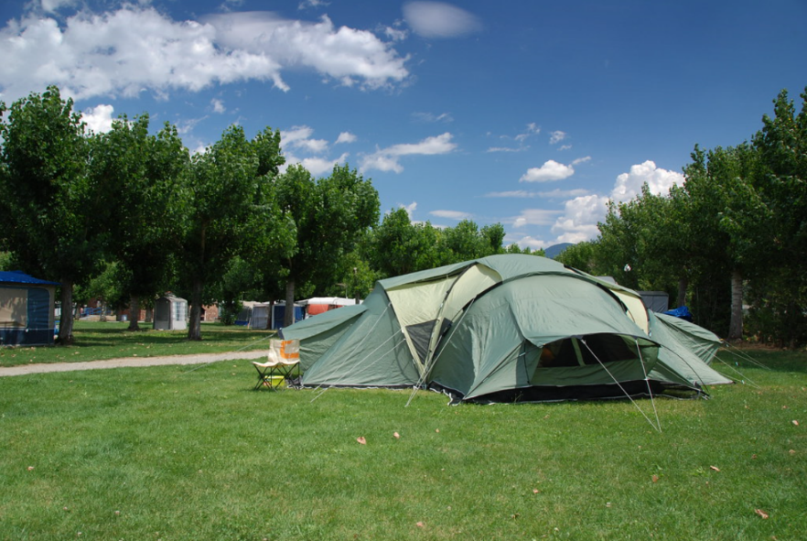
Last year, corona pandemic significantly affected the number of campers. Only 650 people signed up. Now that the amount of infections has decreased, Elina Setälä, the chief of the camp, has her hopes higher for this summer. At the moment, six of the camp sports are already full. Auto racing, cheerleading, frisbee, sport adventure, parkour and show dance seem to be the most preferred
genres this time. Mette Miettinen

The biggest star in future ice hockey
If you follow ice hockey, you should know the name Connor Bedard after 2023 World Junior Championship. Connor Bedard is 17-year-old hockey player from Canada and one of the biggest future stars in the hockey world. For last couple of years this kid has dominated the WHL, which is a junior league in Canada. Bedard plays for the Regina Pats and this year he become the captain of his team.
In season 2021-22 Bedard made 100 points in 62 games for the Pats, and with his 51 goals, he was the second highest scorer in the league. In the WHL, there are mainly 18-20-year-old players and Bedard was 16 that year. This year his numbers are already crazy. He has played 33 games in the WHL this season and he has 81 points. It is 2.45 points per game. He has missed eleven games because he was in World Junior Championship but if he plays all the remaining games, at this rate he will score 140 points.
Last year Bedard played both U18 and U20 World Junior Championships and he made great points in both tournaments. His performance this year in U20 World Junior Championship was mind-blowing. 7 games 9 goals 14 assists and 23 points. This kid is 17 and dominates the best U20 players in the world. Logan Cooley was the second best scorer in this tournament and he has 14 points.
Bedard is so special a goal-scorer. He can shoot the puck so quick and surprisingly, from different positions. The most talked thing is his shooting and scoring but he is much more than that. He is a great passer as well, and skating and puck handling are also at a great level. Defending and playing without a puck are the biggest development targets but he is still young so he has a lot of time to improve those things.
Bedard will be drafted to the NHL next summer and he is almost surely the first pick. There is not a team in the NHL that wouldn’t want Bedard. The points that he makes and how he performs on the ice every night is impressive. This man is one of the best prospects ever and I think he will be one of the biggest superstars in the NHL after a few years.
Niko Kiuru

The Battle for Nürburgring
Nürburgring is a place of great importance for many car enthusiasts and motorsport fans throughout the world, and because of that, some very interesting events have taken place there over its 95-year long lifetime. The Ring has hosted countless races and racing leagues, all the way from the world-renowned Formula 1, to local cycling races.
The other big aspect of Nürburgring is that a lot of manufacturers test their high-end sport cars there. It's a sort of badge of honor to see how fast your car can clear the green hell. This has been going on for almost as long as the track has existed. This means that the official record has changed hands more times than you can count, and it has become a slight competition between certain manufacturers.
Mercedes AMG and Porsche, who many think of as the king of Nürburgring, have been trading the record back and forth for a few years now. Porsche took the record in 2017 with the 911 GT2 RS, and then lost it shortly after to Lamborghini by 3 seconds in 2018. After that, Mercedes took the record by another second in 2020. Porsche, wanting to show that they are still the king, reclaimed the record by a whopping 6 seconds in 2021. Finally, we get to 2022, where Mercedes once again steps up to the throne by a huge 8 second lead over Porsche. 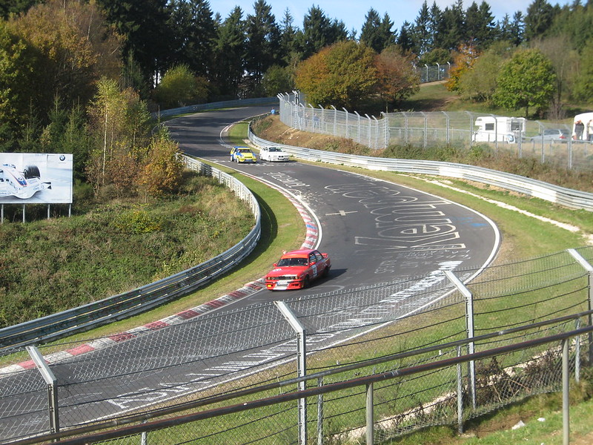
Some people have started to mock Mercedes for taking the record, because the car has almost twice the horsepower of the former record holding Porsche, and costs about ten times as much. Others have also pointed out that Porsche is still technically the overall record holder, just not with a production car. People have also started to speculate about Porsche's revenge, a new and improved 911 GT2 RS hopefully coming sometime next year.
In the meantime, we should all celebrate just how far the car industry has come, breaking records thought to be impossible as recently as a few years ago. Because after all, it isn’t about which manufacturer has the fastest car. It's about improving the industry as a whole, which wouldn't be possible without a bit of friendly competition.
Juho Rantala

Argentina’s road to the World Cup champions
The World cup 2022 was a huge thing for Argentinians and everyone’s eyes were for winning that cup. Maybe the best football player of all time and Argentina captain Lionel Messi is now 35 years old and this is maybe the last time when Messi could lead his team to the World Cup. Lionel Messi has won almost everything that he can won in football but the World cup is the brightest thing he hasn’t won yet. There is no one who thinks that Messi didn’t deserve that. Argentina was one of the biggest favorites to win that tournament and of course this group was full of stars behind Messi.
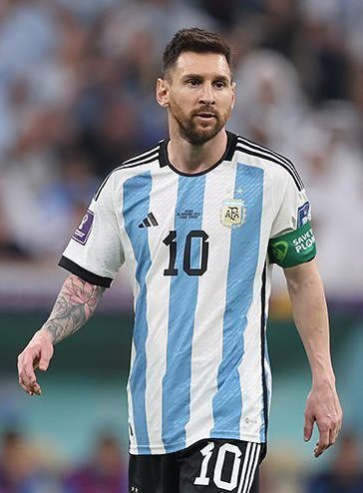 In the group stage Argentina was in group C with Poland, Mexico and Saudi Arabia. Argentina was the favorite candidate to win that group and their place in playoffs was taken for granted by many people.
First game: 22.11.2022 against Saudi Arabia
The tournament started really well when captain Messi put Argentina in the lead after ten minutes with the penalty kick. First 45 minutes were pretty good but bad luck with offsides didn’t make Argentina lead more than 1-0. Second period started like a nightmare for Argentinians. At 48 minutes Saudi Arabia tied the game for 1-1 and soon after that Saudi Arabia took the 1-2 lead with Al Dawsari’s beautiful shot at 53 minutes. Argentina controlled the ball for the rest of the game and made a few very good chances to score but Saudi Arabia’s defense was strong enough. That loss to Saudi Arabia was a shock start for whole Argentina. Next there will be Mexico and Poland against Argentina and they are much more challenging opponents so right after that loss everyone started thinking is Argentina going to drop off after the group stage.
These two games against Mexico and Poland were great performances and Argentina took 2-0 win in both games. With those wins, Argentina got six points and it was enough for the first place in group C, and that first game shock wasn’t too much for this team.

The playoffs begin
Argentina’s playoffs started 3rd of December against Australia. Argentina was a huge early favorite for this game because it was quite a surprise Australia was in the playoffs. Again, captain Messi put Argentina in the lead at 35 minutes and first half was pretty good for Argentina. In the second half Australia made a few good chances to score and Enzo Fernandez’s own goal brought some hope for Australia. It wasn’t enough because Julian Alvarez had scored 2-0 goal twenty minutes before that and the game ended 2-1. Argentina was going to the quarterfinals.

9th of December quarterfinal against the Netherlands. This was the biggest challenge Argentina had this far. The Netherlands has won their group and beat USA in the first playoff match. Again at 35 minutes Argentina took the lead with Nahuel Molina’s goal. For a long time the game seems good for Argentina and Messi scored 2-0 goal with a penalty kick. The Netherlands player Wout Weghorst came to the field at 78 minutes and just five minutes after that he narrows the game to 1-2. In this tournament additional times had been pretty long and in this game too they played more than 10 minutes additional time and the Netherlands had plenty of time to tie the game. At 90+11 minutes the same guy Wout Weghorst tied the game with a surprising free kick pattern.
There was no solution in the overtime and the winner of this game will be decided by penalty kicks. Argentina’s goalkeeper Emiliano Martinez is one of the best in the tournament, especially in penalty kicks. He saved first of the two penalty kicks and Argentina scored first three and the situation looks good. However, the situation evens out when the Netherlands scores next three and Enzo Fernandez fails. Lautaro Martinez has a chance to win the game for Argentina. Martinez’s tournament hadn’t gone like expected but Inter’s superstar succeeds in a tough spot and takes Argentina to the semi-finals.

13th of December semi-final against Croatia. Croatia had played a great tournament this far and won Brazil in quarterfinals, which were one of the best teams in the competition. Argentina is still an early favorite going to the match. Croatia had more possession the whole game but Argentina was able to defend closely and create dangerous counterattacks. At 32 minutes Croatia’s goalkeeper Livakovic fouls an Argentina player in the penalty area. Messi shot the ball into the goal from a penalty kick and the game is 1-0. Just 5 minutes after that Julian Alvarez gets the ball into the goal with a bit of a lucky run and the first half ended 2-0 for Argentina.
Croatia tried to change the game with some shifts but Argentina was too strong. At 69 minutes Messi dribbles himself to the penalty box and passes the ball to the Alvarez and he scores his second goal in the game. 30 minutes left and the game is 3-0 and there was just a little hope left for Croatia. A few good chances for both teams but no goals and the game is over after five minutes additional time. Argentina was going to the World cup final.

18th of December the World Cup Final against France. France was the reining World Cup champion and again this team was one of the best this year. Argentina started so good and the whole first 45 minutes looked like there is dads against boys. At 21 minutes France player Ousmane Dembele fouls in the penalty area and its penalty kick for Argentina. That was so big penalty kick for Messi and he puts the ball behind Hugo Lloris’s back. At 36 minutes Argentina build up a very quick counterattack and Mac Allister’s great pass found Angel Di Maria who changed the game to 2-0. The first half ended and there were no shots for France and just few dangerous attacks.
The second half started and France has started to improve their game. At 79 minutes Argentina center back Otamendi made fouls in the penalty area and France had a chance to narrow the game. France superstar Kylian Mbappe didn’t make a mistake and France was one goal behind. Just one minute after that Mbappe got a new chance and he scored a great goal. France and Mbappe needed just a couple of minutes and they were even. After eight minutes additional time they needed overtime to decide who the World Cup champion was.
There weren’t big chances in the first 15 minutes in overtime but the last 15 minutes were something else. At 108 minutes, Lautaro Martinez’s shot rebound found Messi and he put the ball over the goal line. The game was 3-2 but a couple of minutes before the final whistle the ball hit Argentina player’s hand and France got another penalty kick. Mbappe’s great shot made the game 3-3 and he finished his hat trick in World Cup final. This year’s world champion would be decided by penalty kicks.
France started and Mbappe was the first shooter. Emiliano Martinez got his hands in between but the shot was high enough and sank into the goal. Messi was next and he made it. Next two France shooters missed and both Paulo Dybala and Leandro Paredes scored for Argentina. France fourth shooter was Randal Kolo Muani and he scored in the tough spot but still if Argentina do the next they would be world champions. Gonzalo Montiel stepped in to the penalty box and France goalkeeper Hugo Lloris guessed in the wrong direction. Montiel’s shot found back of the net and Argentina was world champions.
This final and the whole tournament turned out as it should have. One of the best footballers of all time got the crown for his amazing career and the whole Argentina deserved that win. Argentina’s goalkeeper Emiliano Martinez was awarded as the best goalkeeper of the tournament. Enzo Fernandez was awarded as the best young player and Lionel Messi was awarded as the best player in the final and the best player of the tournament. Kylian Mbappe scored most goals (8) in this tournament and was awarded with the Golden Boot.
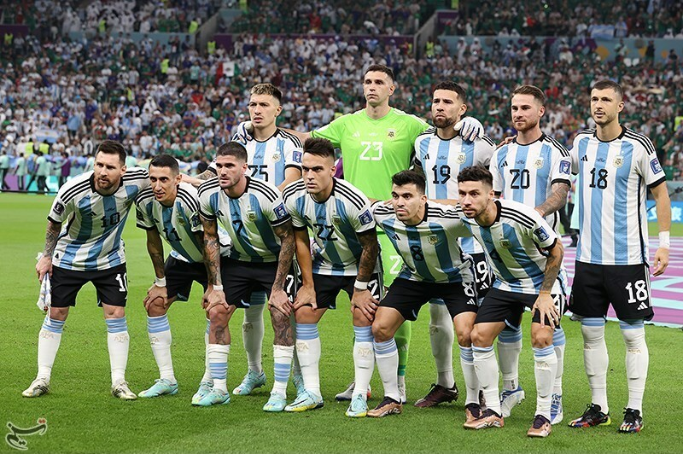 Niko Kiuru

HEALTH
How to sleep better?
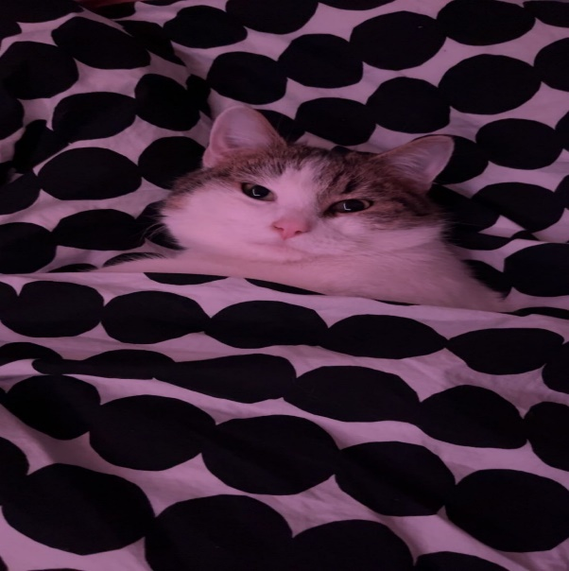
Minttu’s cat “Tappi” showing a good example of how to start a good sleep

What happens if you don’t sleep?
Sleeping and tiredness concerns everyone. A human needs sleep like a phone needs a charger. According to studies, our bodies need about seven to nine hours of sleep. Lack of sleep might cause some health problems like difficulties in focusing and remembering things. If you stay up late and don’t go to sleep when you are tired and your body needs it, you might suffer from headaches.
Lack of sleep affects the whole body not just the head. Think of this for example, you have had a long time when you haven’t been able to sleep well. You might feel some weakness. Then after a couple of days when you relax you will get sick. This is because when you don’t sleep well, your body will get stressed. That will lower your immune system and you might get sick much easier.

What causes sleeping problems?
For example, stressing and exercising before sleeping have the potential to cause sleeping problems. Taking long naps during the day will harm your night sleep. Also, what you eat during the day will affect your sleep. If you don’t eat well, you won’t sleep well.
Also, the biggest problem and the thing that we won’t admit has any effect on us is blue light. Computers and phones produce blue light and it’s a fact that your body will think that it’s not time to go to sleep. The reason why we won’t admit it is because the last thing that we are looking for at night before going to sleep is our phones. That’s because we think that there is always something very interesting that we need to watch. Really, there is nothing interesting. Those TikTok or Instagram stories and videos don’t really matter, and you won’t remember anything that you have seen. It will just keep you awake, and you are going to be tired the next day. But it’s a fact that the light is telling our body that the sun is shining, and it will postpone the melatonin production.
What can you do to help yourself with sleeping problems and tiredness?
Going to sleep and waking up at the same time will train your body to the sleeping cycle. It might be hard in the beginning, but it will get easier when your body gets used to it. Also, eating regularly and having something small to eat before going to sleep will help you. Also relaxing before sleep is important. There are many ways to relax, and everyone can find what works best for them but for example one of them is stretching.
If you have problems falling asleep, try this trick. The next time you are going to sleep, put your phone away thirty to sixty minutes before going to sleep and read a book. It will make you feel tired faster, and you really want to go to sleep because you can’t focus anymore, and your eyelids are becoming heavy. If you think that the book is too interesting, take a schoolbook. I promise that at least then you will get some sleep.
Poll and aftermath
We asked the students in our course about their sleeping habits. Here are the results:
How much do you usually sleep at night and is it enough for you?
Hannu: 3-5 hours Emmi: 8h Minttu: 7-8h Janette: 6-7h
Mette: 8h Noora: 5-8h Aleksi: 6h Niko: 8h
Simo: 2-6h Karri: 6h Juho: 4-7h
Out of all the students only two (Aleksi and Niko) said that they were sleeping enough. Other students felt that they didn’t sleep enough. As you can see from the results, almost all of us think that we don’t sleep enough.
Students especially need the recommended amount of sleep. If you don’t get enough sleep at night, you probably see that the next day at school. Lack of sleep reduces your capacity to study and concentrate. You can find reading and thinking challenging and you feel like the day is never going to end. In the long run lack of sleep will overall affect your studies and exams. This will make you anxious and that’s even worse for your studies. So as a student take good care of your sleep.
Emmi Kangas and Minttu Peltonen

Ice swimming
Ice swimming is swimming in a hole made in the ice. The water is often zero degrees. It is customary to swim in the water for a few minutes tops at a time. Some people also like to go to sauna before or after ice swimming. Ice swimming is a hobby for many. In Finland, about 150 000 people practice ice swimming: around half of them are men and half are women.
Ice swimming has many health effects. For example, it relieves stress and can help with joint pain. Cold water can also prevent inflammations. Ice swimming is also good for athletes because it helps with recovery and can relieve muscle pain. Many people also feel that ice swimming improves the quality of sleep. However, ice swimming is not recommended for everyone. This especially applies to people with heart disease and severe asthma. Momentary exposure to cold is heavier for the heart and affects the bronchus.
In Kokemäki, you can go ice swimming in Pitkäjärvi, for example. There you can ice swim freely at any time but on Wednesdays and Sundays the saunas are also available.
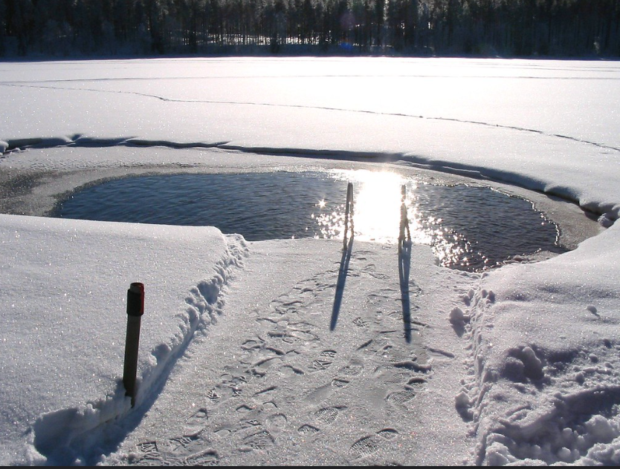 Isabella Lehto

An atypical epidemic is spreading again in Finland
RSV causes respiratory infection for all ages but especially for children and the elderly. It can also cause pneumonia. RSV causes infections usually in winter and it’s getting bad again. The virus burdens the emergency department in many countries.
RS-virus spreads by droplet infection for example through sneezing or indirectly through hands. The disease emerges 4-5 days before symptoms begin.
The flu epidemic has started and there are many different diseases that spread. Influenza a and b, corona, this RS-virus and even pneumonia. Right now, it’s important to take good care of hygiene and wash hands properly to avoid infections. There have been many infections during the last few months.
This winter might be a lot harder than last few years. It’s because during the last few years corona has been at worst and people didn’t move around a lot. The more people move around the more diseases spread and there is a bigger change of getting infected. This RS-virus isn’t the only disease that has been started to spread like for example a and b influenza and corona is still also around.
Noora Kansanaho

What is depression?
Depression is a common illness worldwide, which negatively affects how you feel, the way you think and the way you act. Fortunately, it is treatable. Depression causes feelings of sadness and a loss of interest in activities you once enjoyed. It can lead to a variety of physical and emotional problems, and it can decrease your ability to function at work and at home. Depression can become a serious health condition. At its worst, it can lead to suicide. The symptoms can vary from mild to severe including changes in appetite, weight loss or gain unrelated to dieting. You can have trouble sleeping or you sleep too much. You may feel worthless or guilty about something. More severe symptoms are thoughts of death or suicide, slowed movements or speech.
Ending of a relationship, death of a loved one or loss of a job are difficult experiences to endure. Those who experience losses might describe themselves as being “depressed.” Being depressed is not the same as being sad, because the grieving process is natural and unique to each person, and it shares some of the same features with depression. Both depression and grief may involve intense sadness and withdrawal from usual activities. But they also have lots of differences for example in grief, painful feelings come in waves, often mixed with positive memories of the deceased. In major depression mood or interest are decreased. In grief, self- esteem is usually maintained and in depression feelings of worthlessness and self-loathing are very common. In grief thoughts of death may surface when thinking about “joining” the deceased loved one and in depression these thoughts are focused on ending one’s life.
Depression can affect anyone and there are several factors. Depression can run in families. People with low self-esteem, who are more easily affected by stress are more likely to experience depression. Continuous exposure to abuse, violence, neglect or poverty can make some people more vulnerable to depression.
Depression is among the most treatable mental disorders. Almost all the depression patients respond well to the treatment. Antidepressants are one of the treatments. They can produce some improvement in the first two to three weeks, but the full benefits are seen in two or three months. If a patient feels no improvement after several weeks, they should be in contact with their psychiatrist so they can alter the dose of the medication or add or substitute another antidepressant. It is very important to let your doctor know if the medication doesn’t work, or you are experiencing side effects. Psychiatrists usually recommend using the medication for about six months or more after the symptoms have improved. Psychotherapy is sometimes used alone for the treatment in mild depression. For moderate to severe depression, it is often used along with antidepressants.
Cognitive behavioral therapy or CBT has been found to be effective in treating depression. CBT is a form of therapy focusing on solving the problem in the present. CBT helps the person to recognize negative thinking with the goal of changing thoughts and behaviors to respond to challenges in a more positive manner. Psychotherapy may involve only one person, but it can involve others. Family or couples therapy can help solve issues within these close relationships. Group therapy brings people with similar problems together in a supportive environment.
There are lots of things you can do to help reduce the symptoms of depression. For many people regular exercise helps create a positive mindset. Doing things that gives you a pleasant feeling helps and getting enough sleep on a regular basis, eating healthy and avoiding alcohol can also help reduce depression.
Depression is a real illness and help is always available. With proper treatment most people with depression will overcome it. Talk about your problems and realize that you have them. You aren’t alone.
Janette Prinkkala

FOREIGN

How Finland joining Nato could checkmate Russia
When I started thinking about writing this article, I had no idea it would be this big of a challenge. Today I am going to tell you how Finland joining Nato helps them and how it impacts Russia.
So, to help you understand more about this topic overall I think it's wise to teach you a little bit of Nato and Russia's history together and after that how Finland joining Nato changes things around. Russia has shown aggression against many countries after the Cold War including Moldova (1992-2016), Georgia (2004-2012), Estonia (2006-2007), the Ukraine (2014-present), Syria (2015-present) and Turkey (2015-2016), among other countries. Russia and Nato’s relationships started to crumble after Russia’s first invasion to the Ukraine on 20 February 2014.
Now Putin has seen another obstacle in his plans and that is Finland and Sweden joining Nato. There’s more than a handful of reasons as to why Finland joining Nato is dangerous for Russia and Putin. The biggest problem and danger are something that anyone can guess and that is Finland’s 1,340 km long border with Russia. The border is already large enough reason for Russia to have their guard up but there are at least two more things Putin needs to keep his eyes on, or Russia could fall.
The second largest danger for Russia is Kona Peninsula. Kona Peninsula is a peninsula in the extreme northwest of Russia and one of the biggest peninsulas in Europe. Kona peninsula is Russia’s nuclear testing area, and a large amount of Russia’s nuclear weapons are located there. So, if Kola peninsula were to fall Russia could not compete with the United States nuclear power anymore.
The third reason is two things at once and they are Saint Petersburg and R21 Highway also known as Kola Motorway that travels from Saint Petersburg to Severomorsk that is in Kola Peninsula. These two things are also very important for Putin and if he lost either one it could start World War III. Saint Petersburg, also historically known as Leningrad, is hometown for our beloved Putin so that with its historical meaning makes it already a very important place for Putin. Now the real danger and blind spot for Russia’s military power is R21 Highway that travels almost entirely next to the Finland’s border with at the very least only 100km from the highway to the border. That is a very large problem with the fact in mind that Russia transports a large amount of their nuclear weapons, submarines and their new doomsday weapons called The Poseidon torpedo. If Finland were to destroy this highway it could mean the end Russia.
At the end of the day if we are talking realistically Finland joined Nato for their own defense and it’s said Finland will follow “the Norway model” in Nato. That means that Finland won’t participate in any invading to other countries or other kind of attacks or militarization that the United States could want to try.
Simo Aalto-Setälä

The Ukraine Situation
I chose to write an article about the current situation in the Ukraine and mainly the propaganda part of Russia on it. Since I know Russian language quite well, I was able to understand and tap into some news sources of Russia and read a bit of the propaganda that was going on there.
First of all, after all this time that this conflict has been going on since 24th February 2022 and yet Russian government still dares to call this the little neat special operation and not illegal act of war which they didn’t declare, as by their own words “we are freeing people of the Ukraine from this nationalist government which is torturing them.” and I find this interesting since I have not heard a single proof of their so-called Nationalistic beliefs. In addition, the president is an ex-comedian.
Russia even went as far as to show pictures of a captured soldier on live tv who had his whole body covered in swastika tattoos. There of course was no proof that he was even a soldier or Ukrainian and I couldn’t find that picture anywhere online even after valiant search effort. Well, what can I say? Just a classic attempt of lies from Russia but that is basically how the country has been operating ever since USSR times.
After the start of conflict Russia was hit with a ton of sanctions and Rouble has been losing its value ever since. Even McDonalds has been replaced with “vkysno I tochka” which translates to tasty and that’s it. Must be a really hard time being a Russian citizen right now with all the sanctions and hate floating around. Basically, every foreign company that was big enough to be known worldwide has retrieved its assets from Russian grounds businesswise. And yet they dare to tell their people that it will soon be over and at the same tame mobilizing the army which is clearly incapable of taking the Ukraine on their own.
Russia who advertised their army as great and strong is in the end fighting with old technology which had been rusting on the fields ever since the Cold War. Russia even managed to run out of 152mm artillery shells and was forced to buy them from China of course trying to hide that whole ordeal.
As of 16.12.2022 Russian television news program called Antifake announced that Ukrainian territory controlled by Russia is descending into literal dark age and that they are tying people to poles in broad daylight and beating them to death. Of course, as ironic as it sounds there is no source nor pictures shown of it. Just two guys speaking and trying to be convincing to the audience. Well, I guess the Antifake program isn’t anti fake after all.
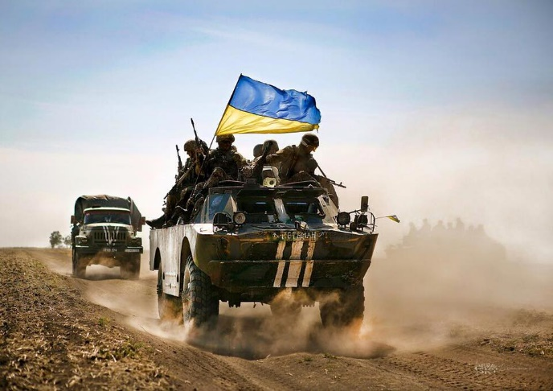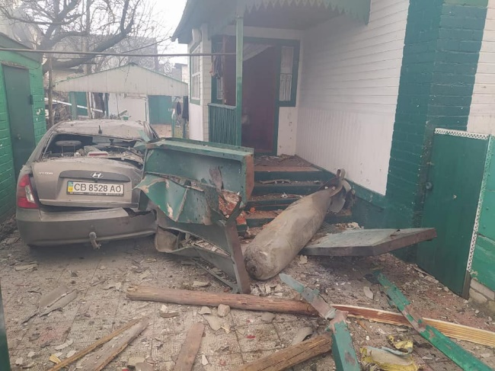
Hannu Neuvonen

Prisoner exchange
On the 8th of December 2022, the United States conducted a prisoner exchange with Russia. The exchange included an American Olympic basketball player Brittney Griner, who had been arrested in Russia for drug possession, and an infamous Russian arms dealer Viktor Bout, who has been aptly nicknamed “the merchant of death”. Bout was arrested in 2008 in Thailand for terrorism-related charges, and his arrest was a joint operation conducted by the royal Thai police, Interpol and the DEA.
The early life of Viktor Bout is largely a mystery, and accurate information about him is rare. Many sources say that he was born in Dushanbe, Tajikistan (which was a part of USSR at the time) on January 13, 1967, with many other dates also being possible. Other sources claim that Bout is an ethnic Ukrainian, who became a Russian citizen in 1991.
Information about Bout’s time in the Soviet military is also scarce, with the only thing that is known for sure is that he graduated from the Soviet Military Institute of Foreign Languages. His education allowed him to become fluent in at least five languages (Portuguese, English, French, Arabic, and Farsi), which allegedly led to him being a translator in the Soviet army.
It's believed that Bout’s role in the Soviet army allowed him to buy surplus military aircraft after the collapse of the Soviet Union, which he used to start his own air freight company. The company, Air Cess started as a legitimate business, offering services to the French government, The United Nations and more. Bout only later started using the company for arms trading when he began to see it as an opportunity to make a profit.
The exchange has caused some unrest on social media, with many people believing that the U.S. got the worse end of the deal and doubting if the release of a notorious arms dealer was a good move, especially with the Ukrainian war still going on. Another thing the public doesn’t particularly like is that there was also another American prosecuted in Russia, who many people think would have been much more of a fair deal. The man in question is Paul Whelan, a former U.S. marine, who was arrested in Russia in 2018 for espionage, and is currently serving a 16-year prison sentence there. President Biden has stated that there was talk about releasing him as well, but no progress has been made so far.
Shortly after his release, upon his return to Russia, Bout was interviewed on RT, a Russian state-run news network, where he said that he doesn’t believe to be of any importance to Russian politics currently. However, he has also later publicly expressed his support for the Russian invasion of the Ukraine, and even joined a political party that strongly supports the invasion. It remains to be seen as to whether or not Bout’s release is going to have any effect on the Ukrainian war.

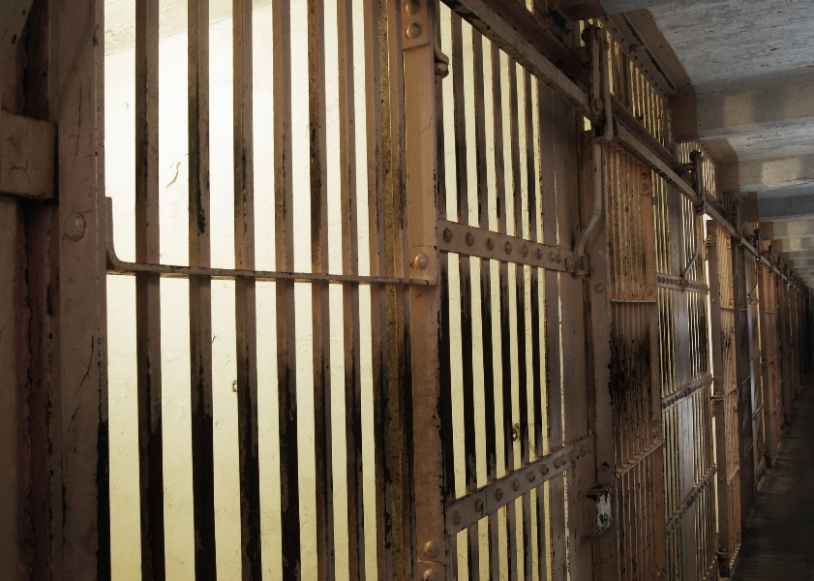 Juho Rantala

CULTURE
Balenciaga drama
To start with, Balenciaga is a big, originally Spanish, fashion house owned by the Gucci group. It designs clothes, jewelry and shoes for both women and men. Many supermodels and other celebrities collaborate with Balenciaga such as socialite Kim Kardashian and supermodel Bella Hadid. Balenciaga is known as a luxury and prosperous company.
In November, Balenciaga published two campaigns. On 16th November, Balenciaga launched its first holiday campaign called “Gift Shop” photographed by Gabriele Galimberti. In the photos of the campaign there were a little children holding a teddy bear bags. The teddy bears wear leather harnesses and BDSM accessories. In one of the pictures there are also many wine glasses on the table in front of the child. The second, office themed, campaign called “Garde-Robe” was launched on 21st November. The campaign included photos where there were a lot of papers in the background. One picture was especially noticeable because there was a page from the Supreme Court laying on the desk. The page was dealing with a child pornography case.
The campaigns weren’t, for a reason, received with open arms. Balenciaga is charged with sexualizing children and advertising child pornography. Demna Gvasalia, who is currently the creative director of Balenciaga, has also been blamed for accepting pedophilia and child exploitation. Photographer Galimberti was charged with the same things as well. The feedback has been the most visible in social media. The hashtag #cancelBalenciga has spread all over media and is now trending on TikTok. People are boycotting the brand and taking videos of them throwing branded clothes to the dumpsters. The celebrities who are known for collaborating with Balenciaga have been attacked by people filling a comment section with hastags and irritated comments.
Many celebrities have taken a stand, too. For example, Kim Kardashian has had her voice on this scandal. As said, she has been an important ambassador for Balenciaga and she has worn many of the brand’s outfits at galas. Now that this scandal took place, she has re-evaluated her working relationship with Balenciaga. On Twitter Kardashian told her followers she was very shocked of these photos as a mother of four child. "The safety of children must be held with the highest regard and any attempts to normalize child abuse of any kind should have no place in our society,” she continued.
A week later, Balenciaga responded to the scandal with apologies. "We sincerely apologize for any offense our holiday campaign may have caused,” the brand wrote on an Instagram story. The brand admits that the bear bags shouldn’t have been featured with the children. Immediately, Balenciaga deleted the Gift Shop campaign from all the platforms. To boot, Balenciaga deleted all Instagram photos and later posted a picture on their Instagram account where they list the actions they will take. At the end of the picture they remind people that Balenciaga stand for children’s safety and won’t tolerate violence or hate speech in any case. The brand also apologies for using the page from the Supreme Court case.
Meanwhile, Galimberti released a statement on his Instagram account where he makes clear that he wasn’t in any way entitled to neither choose the products nor the models. He continues that he was exclusively requested to take the photos according to his own style, that’s all. The designer Demna also apologized later by a personal message on his Instagram account. He writes that he would never use things like child abuse on purpose to provoke a thought by his work. Demna said action will be taken to “avoid similar mistakes in the future”.
Mette Miettinen

Who died in 2022?
Queen Elizabeth II (8.9.2022)
Elizabeth II was the longest serving monarch in the United Kingdom from 1952 to 2022. She was also the head of state of 14 other commonwealth countries, including Canada, Australia and New Zealand. She died at the age of 96 with the official cause of death being old age.
Coolio (28.9.2022)
Coolio (real name Artis Leon Ivey, Jr) was an American rap artist, who became famous for his single Gangsta’s paradise released in 1995. The song was included in the movie Dangerous Minds. Coolio also won a Grammy award with the song. He died at the age of 59 with his official cause of death being cardiac arrest
Shinzo Abe (8.7.2022)
Shinzo Abe was a Japanese politician and Japan's longest serving prime minister. He served two terms as prime minister, from 2006 to 2007 and later from 2012 to 2020. He also worked as the president of the liberal democratic party of Japan during those same years. He was shot during a political rally, causing fatal wounds which led to his death at the Nara Medical University Hospital at the age of 67
Vesa Matti Loiri (10.8.2022)
Vesa Matti Loiri was a beloved Finnish artist, actor, comedian and singer. He is perhaps most well-known for his role as Uuno Turhapuro in the various Uuno Turhapuro movies. Over the years Loiri has had many great achievements, including awards for both his acting and his music. At the time of his death, he was 77, with the cause of death being cancer.
Pelé (29.12.2022)
Pelé was a Brazilian football player, who is often regarded as the best player of all time. He is also the world’s only three-time world champion, along with being one of the most recognizable sports figures of the 20th century. He died at the age of 82, with the cause of death being cancer.
Takeoff (1.11.2022)
Takeoff (real name Kirsnick Khari Ball) was an American rapper, and a part of the popular hip hop trio Migos along with his uncle Quavo and cousin Offset. During his career he received two nominations for the Grammy award, and along with his group Migos got multiple hit songs on the billboard hot 100 list. He was shot and killed at the young age of 28.
Mihail Gorbatšov (30.8.2022)
Mihail Gorbatšov was the leader of the Soviet Union from 1985, all the way until the country's downfall in 1991. He was known for his policies, which helped put an end to the ongoing cold war. Gorbatšov was also awarded the Nobel peace prize in 1990 for “for the leading role he played in the radical changes in East-West relations”. He died at the age of 91 at the Moscow Central Clinical Hospital.
Juho Rantala

The pandas of the Ähtäri Zoo
The government of the zoo has decided that the giant pandas, Lumi and Pyry, will be returned to China. Nevertheless, the final decision will be made in the next board meeting which will be held on February 28.
The zoo published a statement where they told people that the decision is based on cancelling the stimulus package of the Government. The Government had promised to donate five million euros to the zoo for ensuring that pandas can stay in the zoo. Donating would have been a major assistance for the zoo because the upkeeping of the pandas is very expensive and the corona virus has made it even more difficult. Soon, the sum of money was lowered to three millions and now it isn’t granted at all. So the decision of returning the pandas was the best decision because the wellbeing of Lumi and Pyry is the most important for the zoo. “The well-being of the panda duo will not be compromised,” the zoo reports on their statement.
The pandas arrived at the Ähtäri Zoo in 2018. Straight away, they became very popular. In 2018, about 275 000 people visited the zoo. In addition, the income of the zoo rose to 1.2 million euros during the first year. Mette Miettinen

Surviving in Finland’s winter wonderland
The winter is quite odd in Finland. You never know when the actual winter is and the on and off –winter is frustrating. In autumn we start to wait for winter because all the darkness, wetness and leafless trees are making us depressed. But the truth is the god of weather is playing with us the whole time and I don’t think we have never the real winter that we have been waiting for.
How does winter start?
Usually, the first signs of winter are the temperature going below zero and the first snow. But those are just signs and there is a high chance of the snow melting away multiple times before it stays on the ground.
We can have three seasons in one week.
This can happen around the new year. The starting point is darkness and snowless ground. Then suddenly 15 centimeters of snow falls in one night and we have a beautiful scene everywhere. We have a day or two to enjoy the wonderful view before the temperature rises and all the beauty starts to melt away. The following days we have this sunny, wet and warm weather. Winter wheat is growing in fields and birds are singing. Then the rain hits us again and the circle starts again.
In January and February, you might think about spring really coming.
In late January or early February there are signs that spring is coming. The same things happen again. Temperature rises, snow and ice melts, birds flying and singing lovely.
The next couple of weeks you wake up as a new person and feel empowered. You maybe take your summer sneakers out from closet and put on that denim jacket you like to wear in early summer. Everything feels fantastic. And then in one night everything is ruined. The blackthorn winter came. All of a sudden there is again 15 centimeters of snow and 5 degrees frost. You will be lucky if you can wear the summer sneakers again in April.
What can you do to survive this difficult time of the year?
1. Never believe in the weather forecasts. It’s easier to prepare for the opposite weather than the forecast says.
2. The shoes are important! You won’t survive with summer sneakers. Buy waterproof boots because most days you must walk on slush.
3. Listen to something that relaxes you. Between all the darkness, wetness and coldness, you will get to the point where you want to pack all your stuff and move aboard.
4. Even though the weather is horrible, try to go outside. It will help you get in a better mood.
5. Don’t forget that in winter we have Christmas so get yourself a hot cocoa and listen to Christmas music! Maybe winter isn’t too bad after all...
Minttu Peltonen

Waiting for winter all the time
Every year Finnish people start waiting for winter after midsummer. Everyone talks about days getting shorter and the ground becoming white. But I think those are just sayings because winter isn’t coming that fast.
So, I decided to research the dates of the first snow and frost here in Kokemäki in different years. I made two statistics. One tells us when the first snow came and the other one tells us when the first frost was. Both statistics include the past ten years. I used data from the Finnish Meteorological Institute.
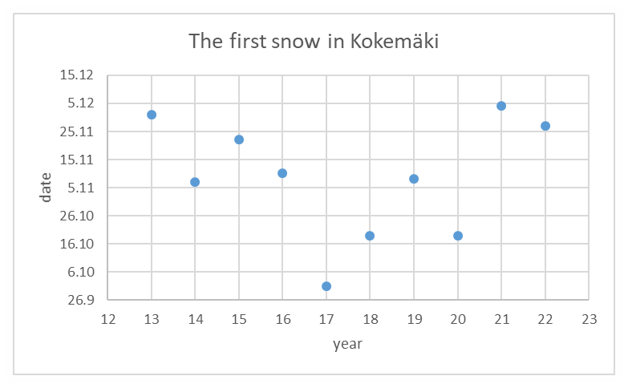
This statistic shows when the first snow has fell on the ground. As you can see the most popular month is November. You can also see that the first snow has fallen in October, November or December. This means we can enjoy late summer and fall before snow enters our backyards.
This statistic tells us the dates of the first frost every year. The most common month is October. Although the first frost has already been in October, the amount of frost has been very small. It may have been freezing for a day or two but after that the temperature has been on the plus side for a week.
This means winter isn’t here right away after the first snow or frost. It takes its own time to come. So, if you tell a foreigner in the summer that the winter is coming don’t be surprised if they look at you strangely.
Minttu Peltonen

Spotify’s most listened songs and artists
Taylor Swift was the second most listened artist in 2022
Spotify is a music streaming service and every year it publishes a list of the most listened songs and artists. Also, every listener gets their own list of what they have been listening to. That personal list will also tell you how many minutes you listened to music on Spotify, and it will create a playlist of your favorite songs.

In Finland
In this year’s list the most listened artist in Finland was JVG and the second was Gettomasa. The most listened song was Ram pam pam from the Finnish artist Bess and the second song at the list was Ammattimies by JVG. The third song was Villieläin by Rames.
JVG was the most listened artist in Finland also in 2020. In 2021 JVG was third on the list but came back this year. Finnish rap music had been on top for many years, and it looks like it’s not going anywhere.
In the world
The most listened artist in the world was Bad Bunny and the second most listened artist was Taylor Swift. She had been on the top of the list also in 2021. The third was Drake. The most listened songs were As It Was by Harry Styles, Heat Waves by Glass Animals and STAY by The Kid LAROI (with Justin Bieber).
My list
According to a summary created by Spotify my most listened songs were A Thousand Years by Christina Perri and Ämmä by Etta. My most listened artists were Justin Bieber, Michael Bublé, Katty Perry, Abreu and Etta. My favorite genre was pop and I listened to music for 17 541 minutes which is 292,35 hours. I also listened to 1 248 different artists and 47 different genres.
Everyone has their own music taste, and some artists will stay listening longer than the others. We can see that on the lists through the years. Many names have stayed there throughout the years 2020-2022. For example, Cheek, Eminem, JVG, The Weeknd and Gettomasa have stayed on the lists through those years.
Emmi Kangas

Umk 2023
What is UMK?
Uuden Musiikin Kilpailu (UMK) is a singing competition organized by Yle. It is open to all music creators and the music style is free. The competition is looking for the best Finnish song and the winner of the competition will represent Finland in the Eurovision Song Contest.
Finlands UMK 2023 in a nutshell
Finland's Eurovision representative will be chosen live on UMK broadcast on Saturday 25.2. at 9 p.m.
Keira, Benjamin, Robin Packalen, Lxandra, Käärijä, KUUMAA and Portion Boys compete in the final.
You can vote during the live final broadcast with the Yle application, by calling and texting.
The Eurovision Song Contest will take place in Liverpool from 9 to 13 May 2023.
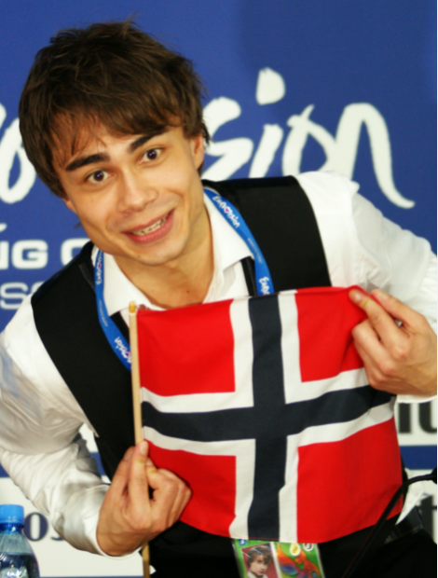
Participants
Keira - No Business On The DanceFloor
UMK's youngest participant, Keira Lundström, who will soon turn 18, wowed Finns in The Voice of Finland with her strong voice. Now she releases the first single of her career at UMK.

Benjamin-Hoida Mut
They say that charismatic and brave Benjamin is "born for Eurovision". He is 25 years old.

Robin Packalen - Girls Like You
The beloved Robin Packalen, one of Finland's most successful pop artists, has been wanted as a UMK participant for a long time, and now it's finally time. Robin, who started out as a child star, is ready to conquer Europe with his energy and authenticity.

Lxandra – Something to lose
The wonderful voice Lxandra, aka Alexandra Lehti, is a magical interpreter and an internationally successful artist. She is 26 years old.

Käärijä – Cha Cha Cha
Käärijä is an artist who cannot be singled out. Shameless and unpredictable, Käärijä loves to break boundaries, go on his own paths and test new things. Käärijä's debut album Fantastista was released in 2020. The artist's music rises to new dimensions live.

KUUMAA – Ylivoimainen
KUUMAA is a three-piece band on the rise, whose core is catchy melodies and great emotions - as well as the friendship between the members that sticks.

Portion Boys – Samaa taivasta katsotaan
One of Finland's best party band, Portion Boys, has a career of more than ten years behind them. With its positivity and sincerity, the band has cleared its way to become one of the most listened to bands in Finland.

What is Eurovision
The Eurovision Song Contest is an annual song contest in which the active member countries of the European Broadcasting Union can participate. Each country participating in the singing competition sends one musical performance to the competition, and they are voted for in the international final.
Rules
Songs must be original and no more than three minutes in length. Lead vocals must be performed live. No more than six performers can take to the stage during any one performance.
Karri Koivula

The Kanye West Incident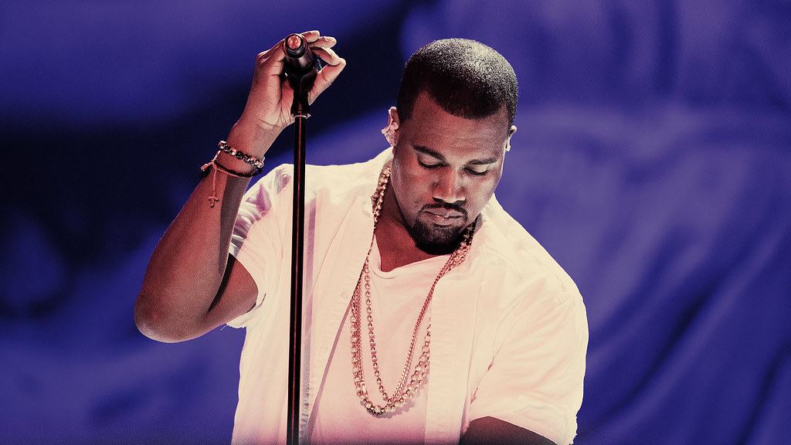
Kanye Omar West now known as just Ye is rapper producer, singer, author and fashion designer. He was born on June 8, 1977, Atlanta, Georgia, U.S. He became famous in 2001 when he produced a couple of songs for Jay-Z's album than ended up becoming hits. Another thing he is known for or rather was known for is the Jeezy brand that he founded in 2015. The reason I said was, is because after the incident that will be discussed further in the topic, he lost all partnership with Adidas who are in control of the Jeezy brand and Adidas said that they will terminate Jeezy business as fast as possible.
Adidas wasn’t the only brand to sever their ties with West. Balenciaga also cut their ties with the artist and GAP told everyone that they would have Yeezy gap merchandise removed from their stores as soon as possible and would also shut down the YeezyGap.com website.
Many people close to West told CNN about his longtime fascination with Uncle Adolf and his political party. His fascination goes as far as almost naming a whole album Hitler, but people managed to convince him to change the name to YE. A business executive who worked for West said that he would create hostile working environment through his obsession with Hitler. He also talked about West openly praising and admiring Hitler and the Nazi party, and that West’s behavior could be classified as harassment. That is probably why he asked to be anonymous in the interview. The executive went on to say that West had spoken openly about reading Mein Kampf which was Hitler’s 1925 manifesto.
Van Lathan JR. A former TMZ employee had confronted West back in 2018. He said West had said things on the podcast like slavery is a choice and made some antisemitic claims. He also said that he heard him openly say that he loves Hitler, and he loves the Nazis but for one reason or another it was cut out of the podcast at the time.
He has also recently done things like wearing a white lives matter shirt at Yeezy fashion show in Paris on Oct 3. He has also posted his and Sean “Diddy” Combs’s Instagram conversation where he said that Diddy was controlled by the Jewish people, after which he made a tweet where he said he would go death con 3 on Jewish people resulting in Twitter locking his account.
Later in his Instagram post “LOVE SPEECH” he referenced his severed ties with business partners and said that he has lost over 2 Billion and is still alive.
Hannu Neuvonen

LoL: Scandalous start of the season
League of Legends is a popular videogame in MOBA genre. MOBA stands for multiplayer online battle arena. It is currently one of if not the most popular game with over 100 million monthly players worldwide and at the time of writing the article 2,474,766 players online. With a player base as big as it is the company responsible for the game, Riot Games has a lot on its shoulders. Riot Games is one of the biggest game publishing companies, having revenue of 1,5billion per year and 2,500 employees.
Player base expects a lot when a company is as big as it is and has been providing a lot of content in the past. Riot Games had set the bar really high up in the past with one of the best cinematics in videogame history. When it was time to release another cinematic for this season’s start it went horribly wrong.
Instead of receiving high quality motivating and epic cinematic, this year players received a butterfly flying around the arena. Yes, the cinematic everyone had waited for for a year was a two-minute clip of a camera patrolling the arena and following a butterfly. The likes and dislikes ratio speaks for itself since it has 33k likes and 275k dislikes.
The backlash from the community was so big that Riot Games had to go on Twitter and make an apology tweet regarding the cinematic and players’ dissatisfaction in it. They also said in the tweet that they had had a rough year and because of the circumstances they were in they had to choose an alternative approach to the cinematic.
Even after the apology tweet most of the community was still outraged about the cinematic. Riot Games must do a lot now to redeem themselves and put themselves back to the level they were at before this fall. Only time will tell whether they will redeem themselves successfully or if this will be the new standard.
Karri Koivula

The Game Awards 2022
The year 2022 was an eventful year, especially in the gaming world.
The year culminated on December 8, when the Game Awards were held. For those who don’t know what the Game Awards is it’s basically an event where the best games of the year are rewarded. The Game Awards have 31 different categories with at least five nominees each, one of which will win. The most known category is the game of the year.
Many games were released this year but two stand out from the rest: Elden ring and God of War Ragnarök. Which also meant that the two games were battling it out for the Game of the Year award. Well, what are these two popular games about? Elden ring is an action role-playing game developed by FromSoftware and published by Bandai Namco Entertainment. It was directed by Hidetaka Miyazaki with worldbuilding provided by fantasy writer George R.R Martin. God of War Ragnarök on the other hand is an action-adventure game developed by Santa Monica Studio and published by Sony Interactive Entertainment. Elden Ring was released for PlayStation 4, PlaysStation5, Windows, Xbox series X/S on February 25, 2022, and God of War Ragnarök for PlayStation 4 and PlayStation 5 on November 9, 2022.
Some of you might be wondering how the winners are chosen. The Game Awards winners are determined by a blended vote between the voting jury (90%) and public fan voting (10%). Fans can vote at the Game Awards official website for the winner of each category. Why don’t fans 100% select the winners, some of you might ask. In the Game Awards frequently asked questions list they say that: “Creating a 100% fan vote presents several challenges. First, given that some games are exclusive to one platform, a public vote puts single-platform games at an inherent disadvantage over multi-platform titles. In addition, it is important that winners cannot be “socially engineered” in any way”. I think this is a smart solution because for example this year’s top winning candidates are from multiple categories: Elden Ring and God of War Ragnarök of which Elden Ring is accessible for five platforms and God of War Ragnarök for only two. Having a blended vote between the voting Jury (90%) and public fan voting (10%) enables all games to have an equally good chance of winning.
Elden Ring was rewarded with the title Game of the year which is given to a game that delivers the absolute best experience across all creative and technical fields. Five games were nominated for Game of the Year: A Plague Tale: Requiem, Elden Ring-Winner, God of War Ragnarök, Horizon Forbidden West, Stray, Xenoblade Chronicles.
To be honest, Elden Ring and God of War Ragnarök were the only ones that could have won this category and when some people really thought God of War Ragnarök could beat Elden Ring it must be at least a decent experience. I personally own both games but I still haven’t had time to play God of War Ragnarök. I have, however, played Elden Ring for approximately 300 hours and I can say that there is only one game better than that which is of course The Legend of Zelda: Breath of the Wild. Elden Ring has vast fantastical landscapes and shadowy, complex dungeons that are connected seamlessly. A wide variety of weapons, magical abilities, and skills are found throughout the world. It has a world you can traverse on foot or on horseback, alone or online with other players, and fully immerse yourself in the grassy plains, suffocating swamps, spiraling mountains, foreboding castles and other sites of grandeur on a scale never seen before. Sounds good? Believe me it is.
Recently Elden Ring has overtaken Naughty Dog's The Last Of Us: Part II to become the most-awarded game of the year winner. Elden Ring has now won a total of 324 games of the year awards.
Karri Koivula

Beauty standards
Beauty standards are very close to our lives. Every time you are on the internet you will come across different ways to make you beautiful and fit in to this society. Beauty standards are very dangerous and they take too much of our time.
Beauty standards are the individual qualifications people are expected to meet in order to embody the beauty ideal that will make you succeed personally and professionally. Beauty standards are often defined in terms of hairstyles, body size and skin color. Beauty standards are different in every country. Some countries prefer people who look slim and some countries prefer people who look thick.
Beauty standards are not always negative but rather they sometimes teach people to take care of themselves. On the internet you can find great tips on how to make your skin look better or how you can have healthy diets.
In Finland beauty standards differ from other countries as well. Finnish people are seen as beautiful if they have light hair and skin. In Japan beauty standards are more precise. Modern Japanese beauty standards tend toward, a slim, petite figure, slender legs, light, flawless skin and a quiet personality.
Nevertheless, beauty standards have lots of negative sides. Many studies have proven how toxic standards directly contribute to depression and anxiety. They can trigger body dysmorphia and disordered eating. These standards can fuel low self- esteem, self harm, and even suicide. All of these conditions have risen in recent years and all of them are connected to beauty standards. People have gone to an unhealthy extent to meet these standards. For example they have gone to plastic surgery or they have started an unhealthy diet. Because all of this people have severe health issues.
Overcoming beauty standards is hard and very time consuming but a way to get started is accepting yourself the way you are. Everyone is different and it is crazy to let these standards try to mold you into something you simply are not. When you accept this, you will no longer feel the need to run after trends and standards. Another thing you can do is staying away from social media. Being on social media is proven to be harmful to mental health. Spending too much time on social media causes sleep disorders, mood disorders and unhealthy eating habits. Staying away from social media is the perfect way to break free of this vicious cycle. It keeps you away from negativity and self- doubt and it also gives you time to work on yourself.
While there is a bad side to social media, there is also a good side to it. There are many influencers, celebrities and sites promoting body positivity. There are a number of movies, blogs and documentaries that empower body positivity, and help people see themselves as worthy. Positive affirmations can help you break free from the boundaries of beauty standards. Find things about your body that make you feel grateful and write them down. You can also write about the things that you want to work on. Another thing you can do is practice non-judgment. Being judgmental about someone else’s appearance can also put pressure on yourself. You should see the beauty in all shapes and sizes and it will help you accept yourself. Love yourself and remember anyone can hide behind filters and make-up, but true beauty comes from inside.
Janette Prinkkala

A fairytale castle in the middle of the German countryside
One of the landmarks of Germany the Castle Eltz is located by the river of Mosel. Throughout its history, the castle has been owned by the same family. The castle is located 150 kilometers from the center of Frankfurt am Main.
The oldest parts of the castle are from the 1100s. Over the centuries, the castle has been divided into different branches of the family, who owned their own part of the castle. That’s why the castle has got its own unique style.
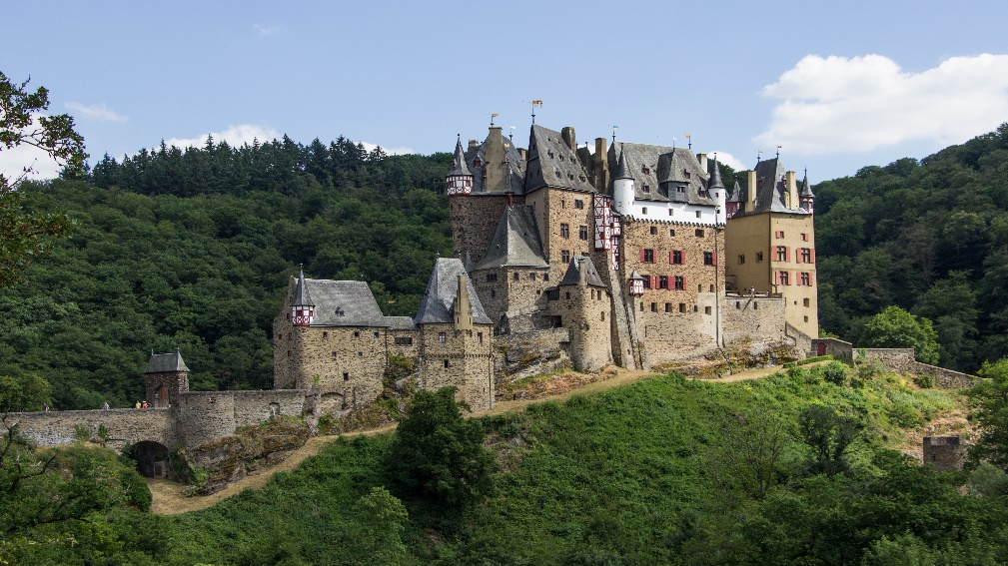
Ever since the 12th century, it has always been the oldest son who was responsible for Eltz Castle. Today the head of the family is Count Johann-Jakob zu Eltz. He took over the management of the castle in 2018 after his father's dead. Currently the castle is in the hands of the 34th generation of the family.
What makes Eltz castle even rarer is that it has remained undamaged from many wars in history, even from the Second World War. As a result, visitors get to fully admire the original interior and buildings.
Guided tours are organized in the castle and a tour around the castle takes about 45 minutes. Tourists should come immediately in the morning or arrive after three o'clock in the afternoon to avoid peak hours. This way you will probably get a more pleasant experience from visiting the castle.
The castle has been considered such a significant symbol of Germany that it was printed on a 500 German mark between 1961-1995.
Aleksi Forsberg

Palaces, Castles and beautiful estates, great homes of British royal family

Today's most famous royal family in the world owns plenty of beautiful buildings and some of the buildings you can also visit yourself. In this article we will focus on seven of them.
Buckingham palace
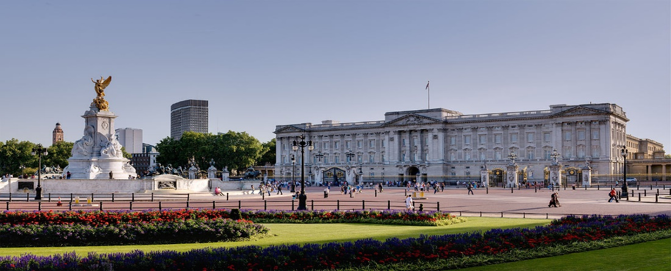
Buckingham Palace is one of the world’s greatest royal residences and itself is a major tourist attraction in the UK. Buckingham Palace is the official London home of the reigning British monarch.
Formerly known as Buckingham House was built by the Duke of Buckingham in 1703. King George III bought it for his wife as a private residence in 1761. In the 1820s King George IV started its expansion and transformation into a royal palace. Queen Victoria became the first British monarch who took the Buckingham Palace to official London residence in 1837.
Buckingham palace is the centre of all national activities and significant occasions concerning the sovereign.
There are 775 rooms in Buckingham Palace, which has witnessed expansions and modifications throughout the 19th and 20th centuries. Visitors are allowed to explore the 19 state rooms of Buckingham Palace every summer.
Balmoral Castle
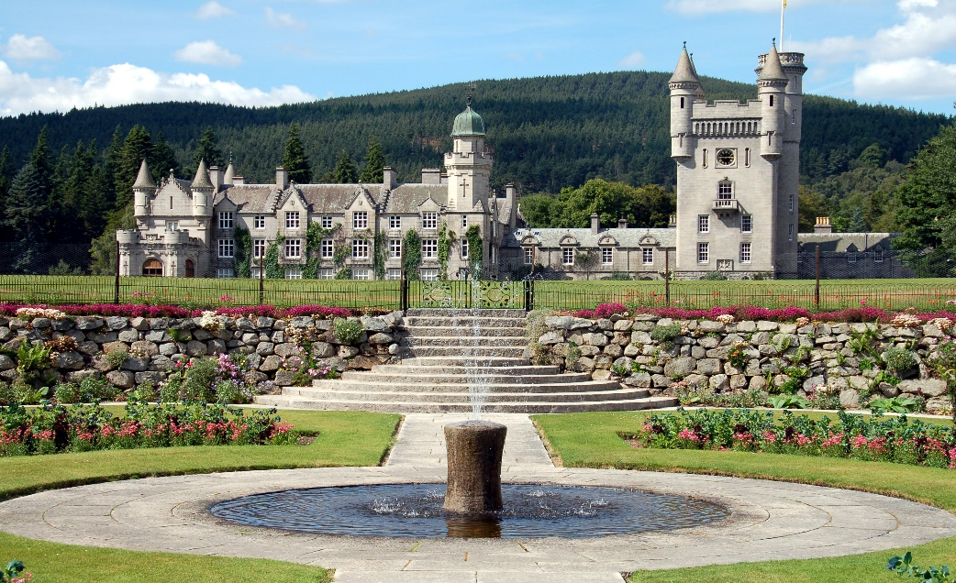
Balmoral castle is the most famous private residence of the British royal family. Balmoral castle is located in Scotland Aberdeenshire.
The estate and its original castle were purchased for Queen Victoria by her husband, Prince Albert, in 1852. The current castle was built between 1853 and 1856 to replace a smaller castle. The castle was designed by architect William Smith along with the prince and it is a great example of Scottish baronial style.
Balmoral Castle has been a private property of the British sovereign since its construction, and it serves as a Scottish holiday home. The castle is not part of the crown estates which controls most of the British royal residence and it is privately owned by the sovereign.
Balmoral Castle is a popular tourist destination. The castle is open for visitors during the summer months. In addition to the castle, visitors will be delighted by the gardens and parks surrounding it. If you want to experience a nuance of history, there are some holiday cottages that can be rented on the grounds of balmoral estate or nearby.

Windsor Castle
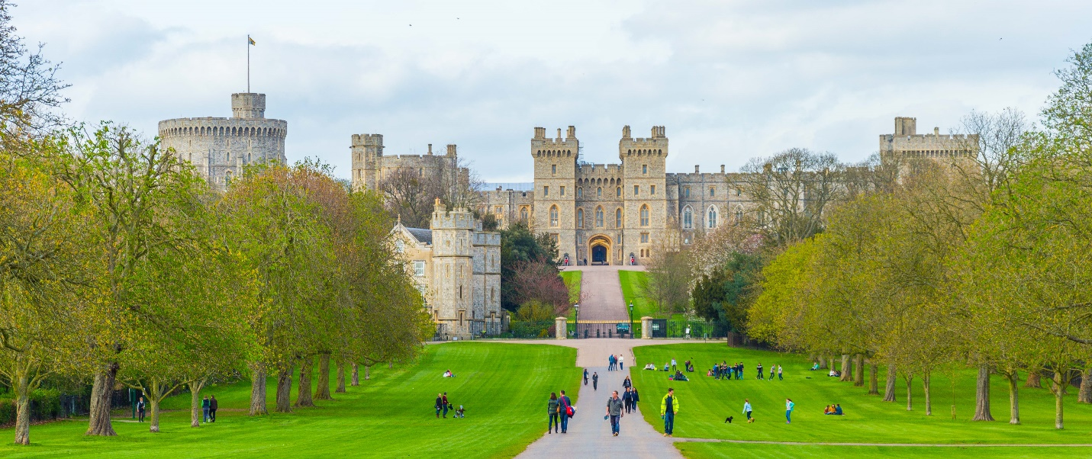
The oldest royal residence in the UK is located in Berkshire, about half an hour's drive from London.
Windsor Castle was originally founded by William the Conqueror over 900 years ago. It is continuously inhabited and expanded or modified since the castle is one of the buildings in royal family’s possession. Queen Victoria made few minor changes to the castle, which became centre for royal entertainment for much of her reign.
Windsor Castle was used as a refuge by the royal family during the Luftwaffe bombing campaigns of the Second World War. Windsor Castle survived the Second World War undamaged. It has been rumored that Hitler did not bomb Windsor Castle because if the Nazis had succeeded in conquering Britain, Hitler would have made Windsor Castle his British headquarters.
Although Windsor Castle is still used as a residence, it is also open to the public all year round. The walls of Windsor Castle are quite an impressive sight on the horizon and the castle attracts up to half a million visitors a year.

Sandringham House
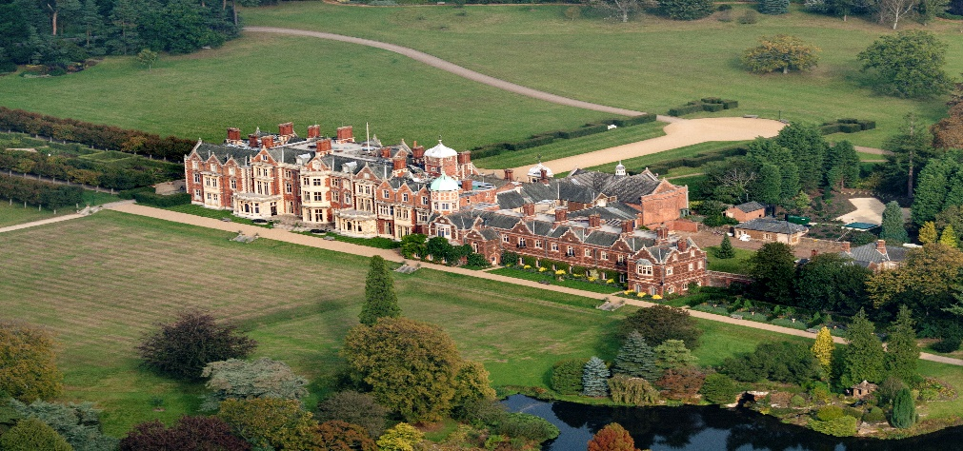
The manor is located in Norfolk in a village called Sandringham. The Manor became the property of the royal family when Queen Victoria bought it for her son Crown Prince Albert Edward as a residence. The manor is still privately owned by the royal family and serves as their holiday home.
Queen Elizabeth II Opened Sandringham House to the public in 1977. In addition to the manor, the property includes a 24-hectare garden and extensive park and forest areas. The most significant attraction of the garden is the 800-year-old Veteran Oak tree.

Kensington Palace
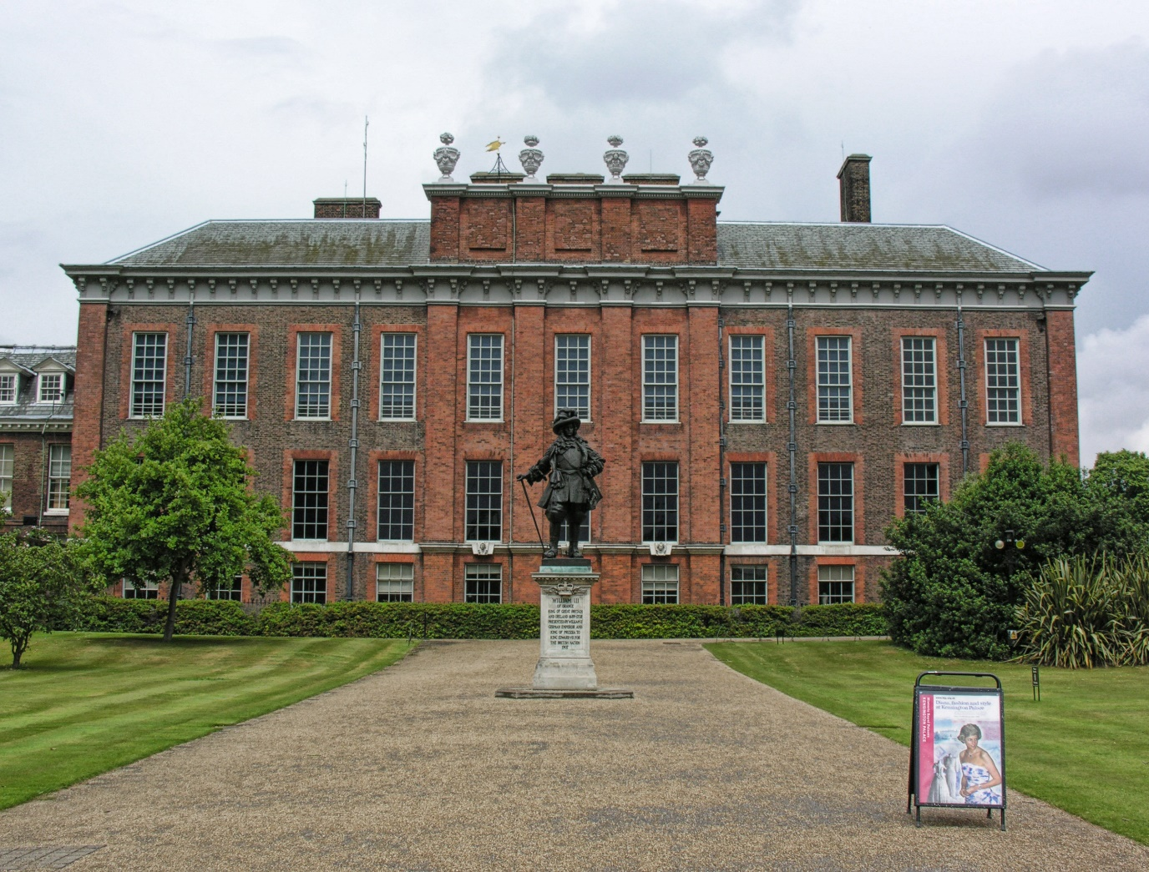
Kensington Palace is a unique example of both an occupied royal palace and historic open to the public.
Kensington Palace is currently used as the official London residence of the Prince and Princess of Wales, Duke and Duchess of Glouster and Duke and Duchess of Kent.
Originally Kensington palace was known as Nottingham house. It was purchased by King William III in 1689. It was used as the favorite residence of British sovereigns till death of King George II in 1760. Palace was also the birthplace of Queen Victoria who also lived in the Palace until she became Queen. Apart from Queen Victoria, Queen Mary, who was grandmother of Elizabeth II was born at Kensington Palace in 1867.
Kensington Palace is partially opened to the public. The gardens of Kensington Palace are also a famous attraction, and it is most beautiful in the springtime.

The palace of Holyroodhouse
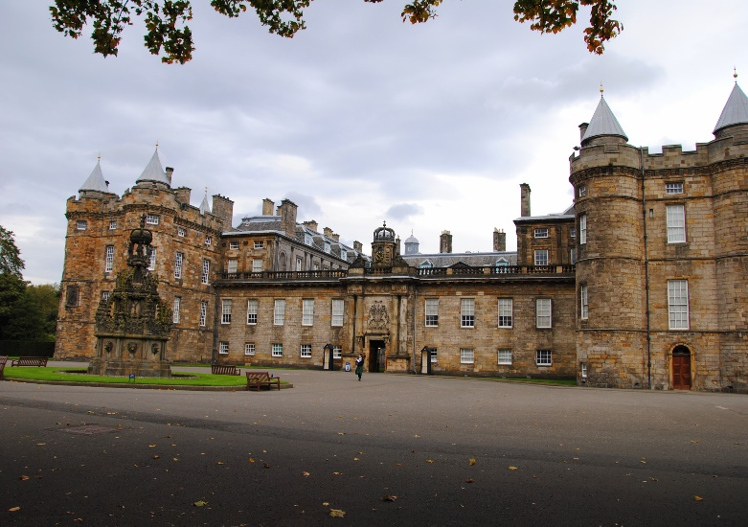
The Palace of Holyroodhouse is the official residence of British monarch in Scotland.
The site where the palace stands today was once a 12th-century Augustine monastery in Edinburgh. In 1501, King James IV built the palace. Successive Monarchs added to the structure, giving it the larger size, it is today.
King Charles II was crowned in the palace in 1651. His vision led to the enhancement of the building and its beautification with plasterwork ceilings and richly decorated rooms. He also constructed an upper floor for private apartments of the royal family.
The late Queen Elizabeth II spent one week in the Palace at the beginning of each summer, where she carried out a range of official engagements and ceremonies.
Hillsborough Castle is open to the public all year round except on holidays or during state visits. In connection with the palace are also the ruins of an old monastery and a beautiful garden.

Hillsborough castle
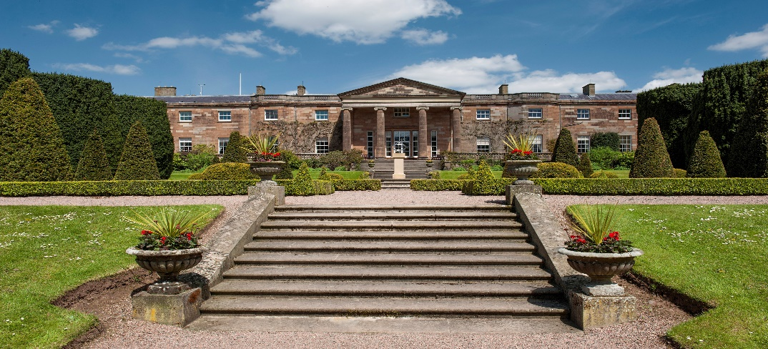
Hillsborough castle is the official residence in Northern Ireland of the British Monarch and other members of the British Royal family.
Hillsborough castle Is located in the village of called Hillsborough in the north-west of county Down. Hillsborough castle is not a true castle, but it is a Georgian country house built in 18th century for the Marquesses of Downshire who owned it until 1922 when 7th Marquess of Downshire sold the manor and estate to the British government. From 1924 to 1973 the castle was the official residence of the governor of Nothern Ireland.
Today the castle is the official residence of the British monarch in Northern Ireland. The last time when a member from a royal family visited Hillsborough Castle was when King Charles III and the Queen Consort responded to an official message of condolence from the Northern Ireland government.
Hillsborough Castle is open to the public all year round except on holidays or during state visits.
Aleksi Forsberg

